  - AVBT ENTERPRISES
#134/19, Seva Niketan Solan. HP | 173212
Ph. +91 8979768681 | info@guzo.in

November 14, 2024

Invoice #000134
Bill to
Customer | SHEDS
Address
Contact

Qty. | Item# | Description | Unit price | Discount | Total
500 | 1 | Visiting Cards with round cutting | 2.5 | 50 | 1200.00
 |  |  |  | Total Discount | 50
 |  |  |  | Subtotal | 1200
 |  |  |  | Sales Tax | 0.00
 |  |  |  | Total | 1200.00
Thank you for your business!
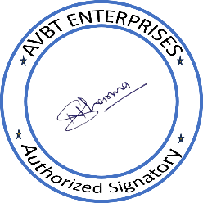
AVBT ENTERPRISES
#134/19, Seva Niketan, Near ITI Solan. HP | 173212
Ph. +91 8979768681 | info@guzo.in

